**HTML ASSIGNMENT**

**SCREEN SHOTS OF WEB PAGES 0LD vs NEW**

**(I used JavaScript and JQuery to add Buttons, Slide Panel, Toggle buttons to hide/show division , used an embedded map inside panel’s division).**

**Codes used are from W3.Schools only but are self customized.**

HOME PAGE:

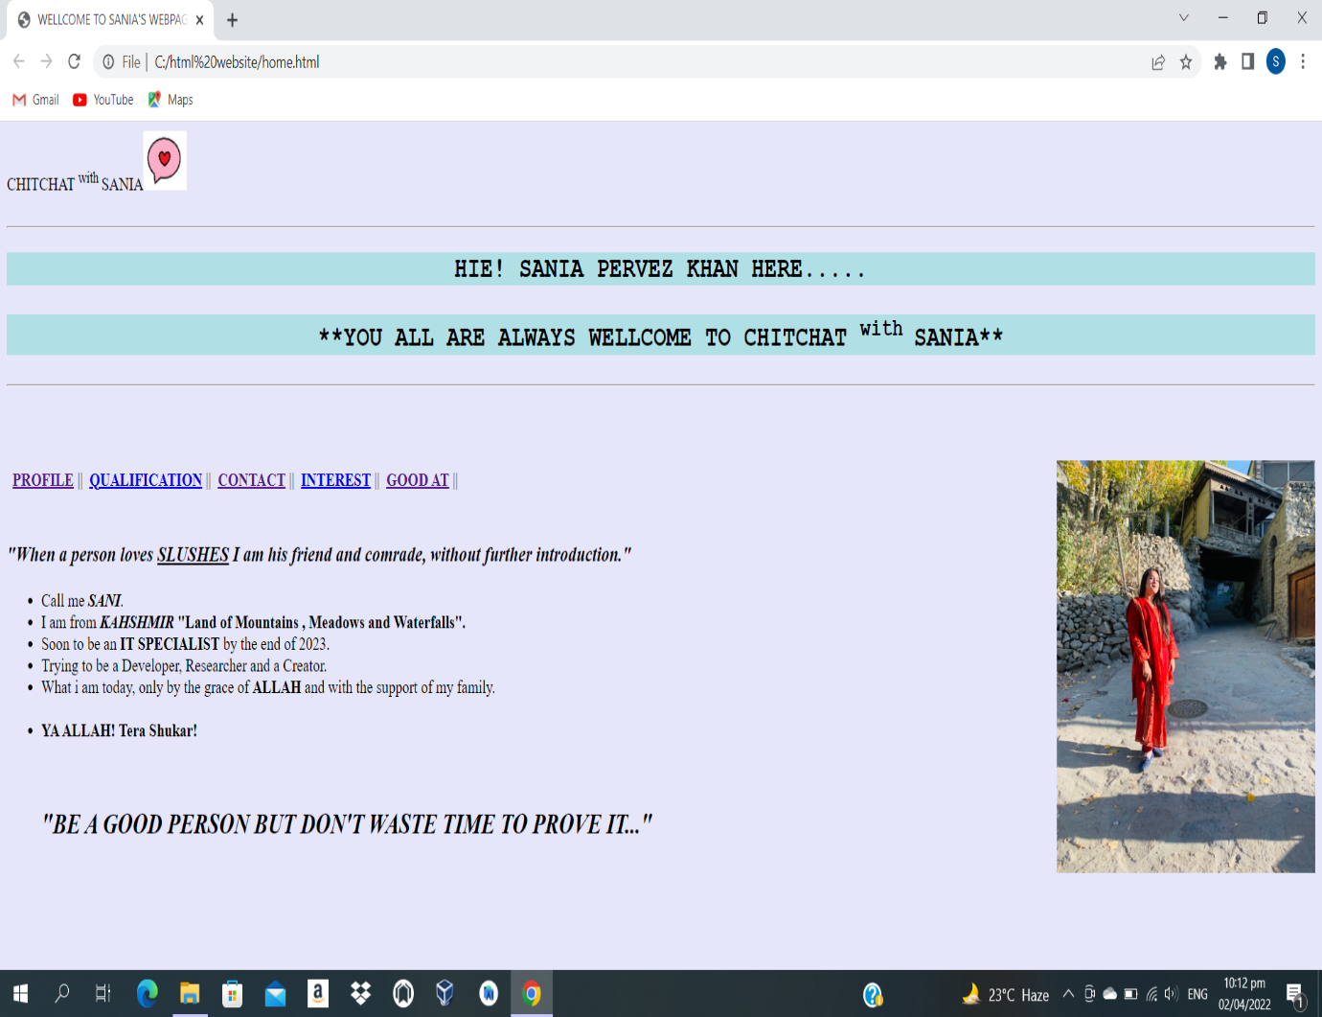

**NEW:**

I have used Java Script to ad **Hide/Show button** for the division.

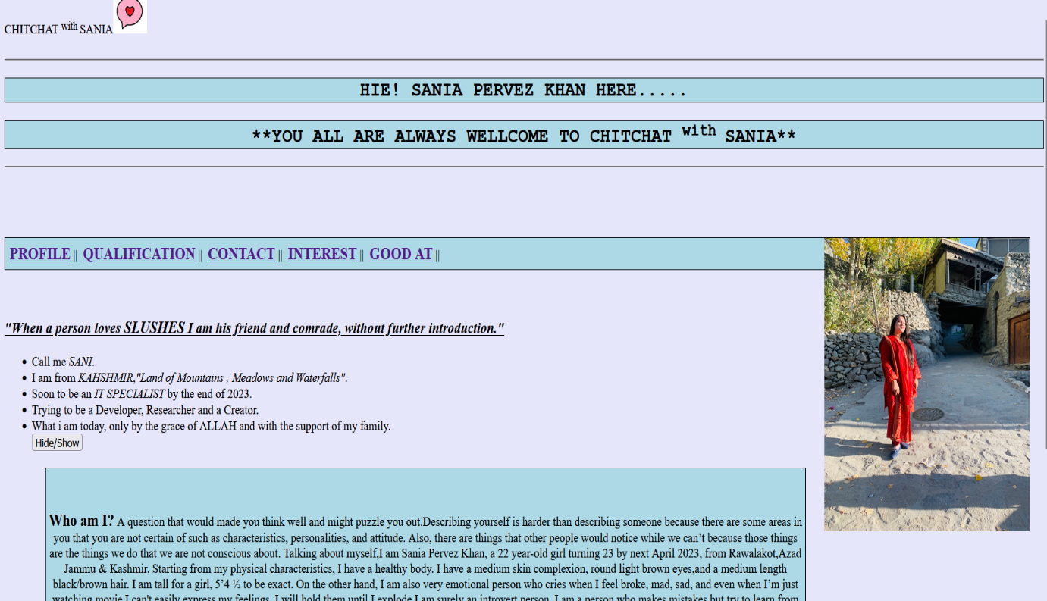

QUALIFICATION PAGE:



**NEW:**

In this page, I have used Java Script to **toggle Read more/ Read less button** as well as I have used JQuery to add the **slide panel**.



C0NTACT PAGE:

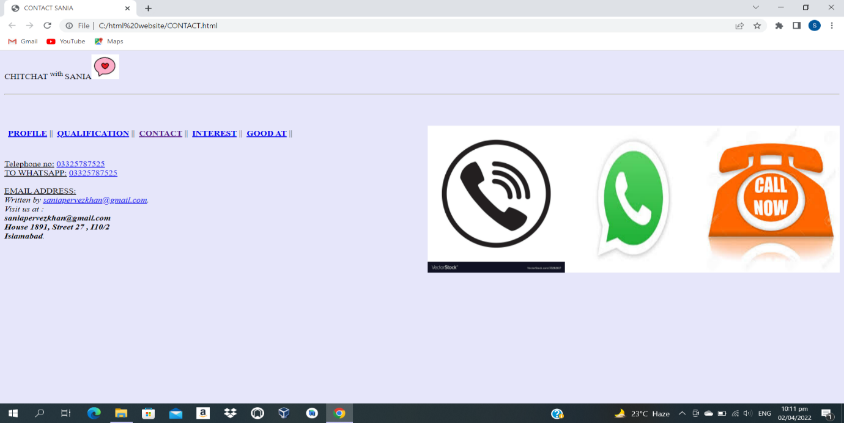

**New:**

i have used javaScript to add **slide down panel** and then I have added an **embedded google map** in the slide down division.

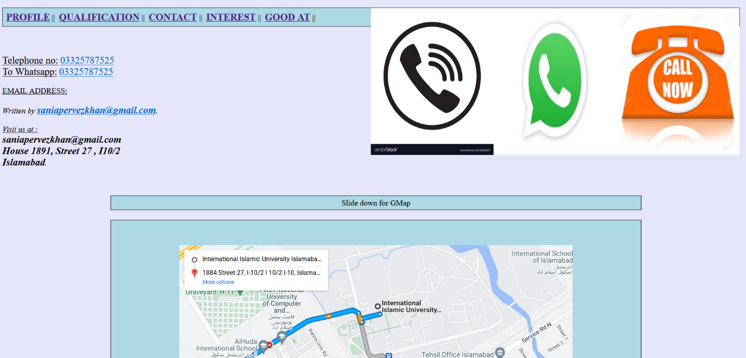

INTEREST PAGE: (OLD/NEW page is same)

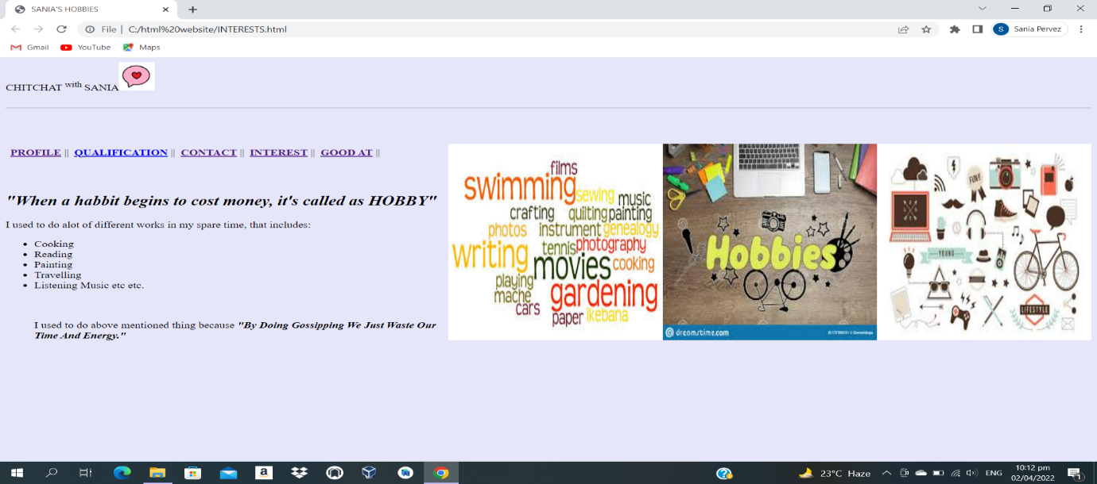

GOOD AT PAGE:

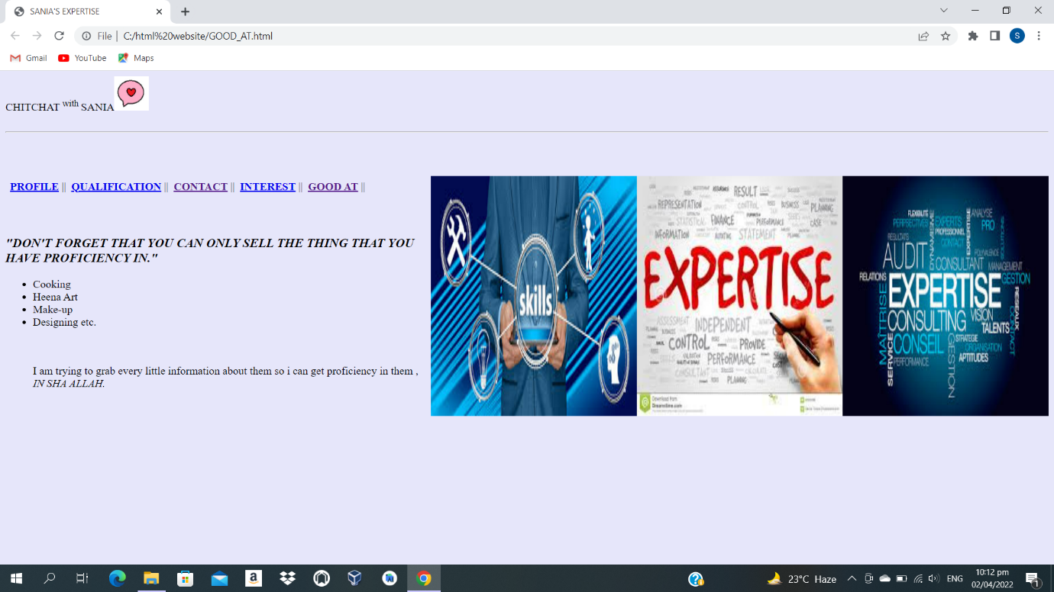

**New:**

In this webpage, I have used javaScript to add a single button that **toggle between read less/read more option**.

